Windows 10 Home running fine for more than a year, then I get a message that Windows 10 Build 1607 updates wont install:
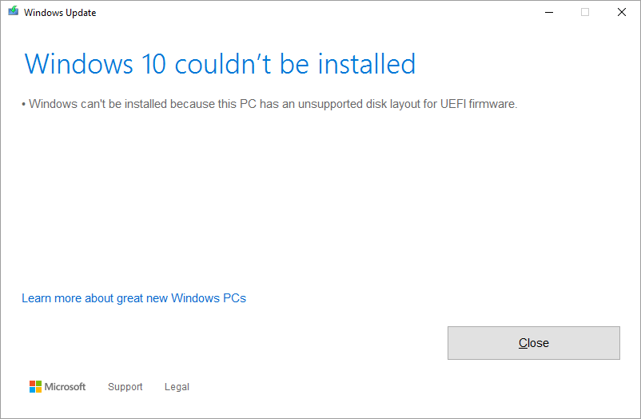

Current windows version is
Windows 10 Home Version 1511
OS Build: 10586.1045
MOBO: Gigabyte X99
BIOS version: F22

